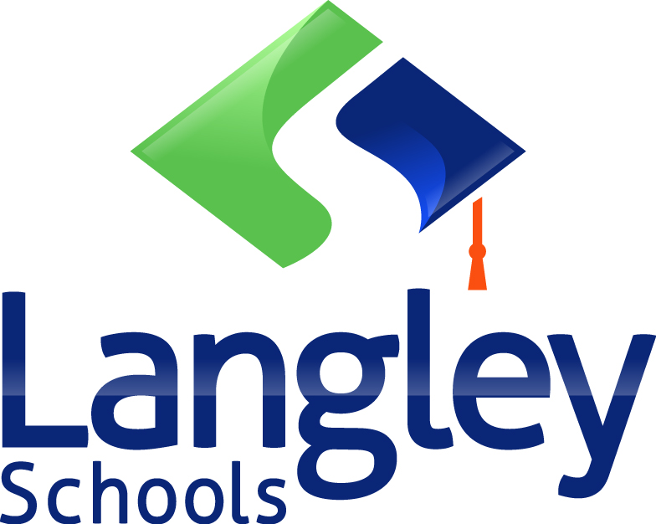 | Board/Authority Authorized Course Application

School District/Independent School Authority Name:  School District #35 (Langley) | School District/Independent School Authority Number (e.g. SD43, Authority #432):
Developed by:  Kayla Preston, Jill Steacy | Date Developed:  February 19, 2018
School Name:  Langley Fine Arts School | Principal’s Name:  Jon Bonnar
Superintendent Approval Date (for School Districts only): | Superintendent Signature (for School Districts only):
Board/Authority Approval Date: | Board/Authority Chair Signature:
Course Name:  Visual Art Studio Explorations: Book Binding | Grade Level of Course:  Grade 10
Number of Course Credits:  2-credit | Number of Hours of Instruction:  Semester course; 3-hours per week

Board/Authority Prerequisite(s):

N/A

Special Training, Facilities or Equipment Required:
Teacher must be a practicing visual artist and educator in at least three of the required disciplines for this course.
Students must have access to an art studio space equipped with appropriate tools and electrical outlets.

Course Synopsis:
Students explore the art of bookbinding and learn how to make their own journals and sketchbooks. This class will introduce students to the art of making books. Students will develop new skills, become familiar with binding tools and techniques and create a variety of different types. By the end of this class, students will understand all the basic skills required to construct their very own books, using almost any material.

Goals and Rationale:
This is a technique driven course where students will learn the differing techniques for making a variety of books (i.e. accordion, long stitch, cased in, soft and hard bindings, etc.). By learning the rules, processes, and procedures to making a book, and by following the rules multiple times, the students can then break the confines of the rules to create an object to be used by self and others.
The students will bind blank sketch/note books that will become the vessel for their ideas, sketches, and research. A place/space they create for themselves. This process will examine the power of the handmade object to increase value, whether done for personal use or as a gift.
In examining value, students will reflect upon the history of book binding and how the creation of the printing press allowed for the mass production of information and ideas. Once a book is bound it becomes substantial and real – the idea becomes tangible and cannot be erased.
The course is designed to develop technical skills through the creative process and exploration of multiple techniques focused on bookbinding. Through exposure to these processes and technologies the students will be better equipped to make aesthetic decisions, create a personal body of work, and reflect upon the historical and contemporary aspects of book binding.

Goals:
- Introduction to the differing techniques of book binding
- Relevance to a contemporary art practice
- Safety in the studio and safe use of equipment related to book binding
- Recognize that the creative process is flexible and requires resilience
- Development of their own artistic voice
- Honor the history of binding and mass producing ideas and the potential for future growth
- Develop skills that can be transferred to other artistic disciplines
- Gain satisfaction with final product(s) through a commitment to the process

Aboriginal Worldviews and Perspectives:
- The development of artistic skills supports the connection between self and others. It works to promote relationships through the creation of visuals.
- Learning the discipline(s) requires an awareness of its history and potential legacy.
- The creative process involves personal reflection and the ability to develop their own unique personal voice.
- Students experience learning through contact with the materials, processes and techniques.

Course Name: Visual Art Studio Exploration: Book Binding Grade: 10

BIG IDEAS
Growth as a visual artist requires patience, time, reflection and exposure to a multitude of mediums. |  | Exposure to a wide variety of materials and processes offers unique ways of exploring ones identity and sense of belonging |  | The learning and refinement of skills is imperative to the development of an artist. |  | To create and display a body of work requires personal decision-making and ownership. |  | The introduction to a wide variety of techniques provides opportunities and increases future options.

Learning Standards
Curricular Competencies | Content
Students are expected to do the following:  Exploring and Creating:  - Create artistic work collaboratively and individually using imagination, observation and inquiry  - Experiment with artistic possibilities with a wide range of materials, processes and technologies  - Express meaning, intent, emotions and feeling through the creating of visuals  - Combine materials, processes and technologies in a variety of ways  - Investigate and identify ways that creating visual art allows artists to reflect on, or respond to, social ad environmental issues.  - Demonstrate active and disciplined engagement in creating works of art and resolving creative challenges  - Demonstrate development of skill and mastery of specific techniques relevant to each artistic discipline  Reasoning and Reflecting:  - Evaluate and critique design choices in 3-D works  - Apply critical, creative, and reflective thinking skills in the exploration, design, creation and refinement of visual art pieces  - Recognize knowledge and skills from other areas of learning in the planning, creating, interpreting and analyzing of artistic creations  - Develop personal answers to aesthetic questions  Communicating and Documenting:  - Share, research, document and appreciate a variety of artistic methods in a variety of ways and contexts  - Create works of art with an audience in mind  - Communicate ideas and express emotions through the creation of visual art works  - Demonstrate respect for self, others and place through the use of materials  - Reflect on their own choices in regard to finding and displaying their personal voice  Connecting and Expanding:  - Create personally meaningful artistic works that demonstrate an understanding of, and appreciation for, personal, social, cultural, environmental, and historical contexts  - Explore Aboriginal perspectives and knowledge, other ways of knowing, and local cultural knowledge to gain understanding through the creation of 3D artwork  - Adapt learned artistic skills or processes for use in new contexts  - Demonstrate safe use, care and maintenance of tools, equipment, materials and work space | Students are expected to know the following:  - visual art elements, principles of design, and image development strategies, including but not limited to:  - elements: line, shape, texture, colour, tone, values, form, space  - principles of design: balance, contrast, emphasis, harmony, movement, pattern, repetition, rhythm, unity  - image development strategies: abstraction, compression, minification, magnification, simplification, juxtaposition, fragmentation, elaboration, distortion, metamorphosis, thumbnail sketching  - concepts related to the creation of art through the technique of carving  - the historical content and its relevance and impact on the discipline  - the significance of the practice on a global scale  - the usage of the specific discipline in a contemporary art practice  - the safe, responsible, and careful use of tools  - the process of aesthetic decision making  - the meaning of cultural appropriation and plagiarism and its affect on society  - the personal and social responsibility that comes with being an artist and producing visually based works  - the physical and/or chemical properties of the materials and the process of working with them safely  - ways of utilizing and/or recognizing the discipline within media

Recommended Instructional Components:
- Direct instruction
- Demonstrations
- Modeling
- Experiential learning
- In-class critiques
- Reflective writing
- Sketch-book work
- Research and presentation

Recommended Assessment Components:
- Assessment of the sketchbook
- Feedback and assessment of research; idea-development; and final product
- Self-assessment of process and final product
- Peer-assessment
- Rubric-based assessment of individual projects: criteria and rubrics to determine the standards met and the level of performance attained.
- Teacher assessment of the collection of student work looking for a demonstration of strengths, areas of growth, and areas for further development

